Complaint form (Service User version)

Date
Service User
Did something happen?  Tell me what happened? | YES NO
Where did it happen? | School Home Swimming pool  Skate park Soft play Park  Car Shop Toilet  Somewhere else?...........................................................
How did it make you feel? | SAD HAPPY ANGRY UPSET  EMBARRASSED SCARED FRIGHTENED  CONFUSED FRUSTRATED HURT
Who were you with? | MUM DAD CARER  TEACHER FRIEND STRANGER  Someone else?...........................................................
What did you do?

Who will resolve this
How was it resolved?
Actions going forward?

Date
Service User
Did something happen? | YES   | NO  
Tell me what happened?

Where did it happen? | School  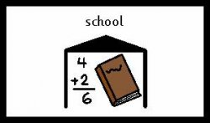 | Home  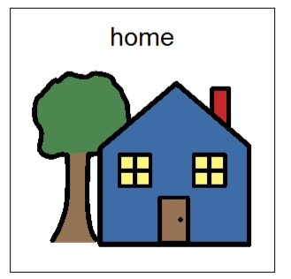
Swimming pool  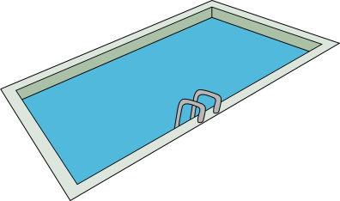 | Skate park   | Soft play  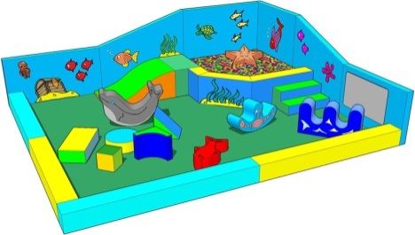
Park   | Car  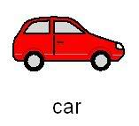 | Toilet  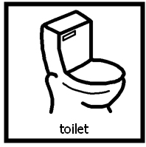
Shop  | Somewhere else?....................  
How did it make you feel? | SAD   |   HAPPY
ANGRY   | HURT   | EMBARRASSED  
Scared   | FRIGHTENED   | CONFUSED  
FRUSTRATED   | WORRIED  
What did you do?

Who were you with? | MUM | DAD
CARER | TEACHER   | FRIEND  
STRANGER | Someone else?  ..............................................  ..............................................

Who will resolve this
How was it resolved?
Actions going forward?

